**6. Setting up a Jenkins Pipeline.**

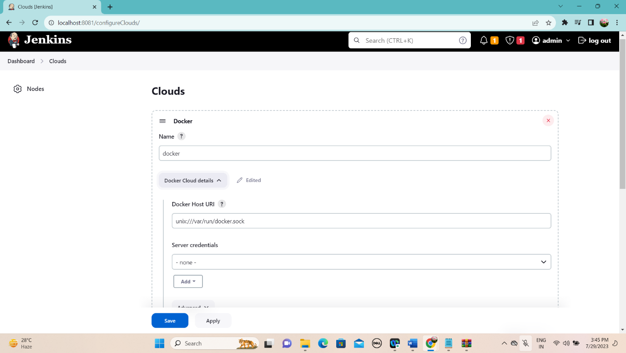

**chmod 777 /var/run/docker.sock**



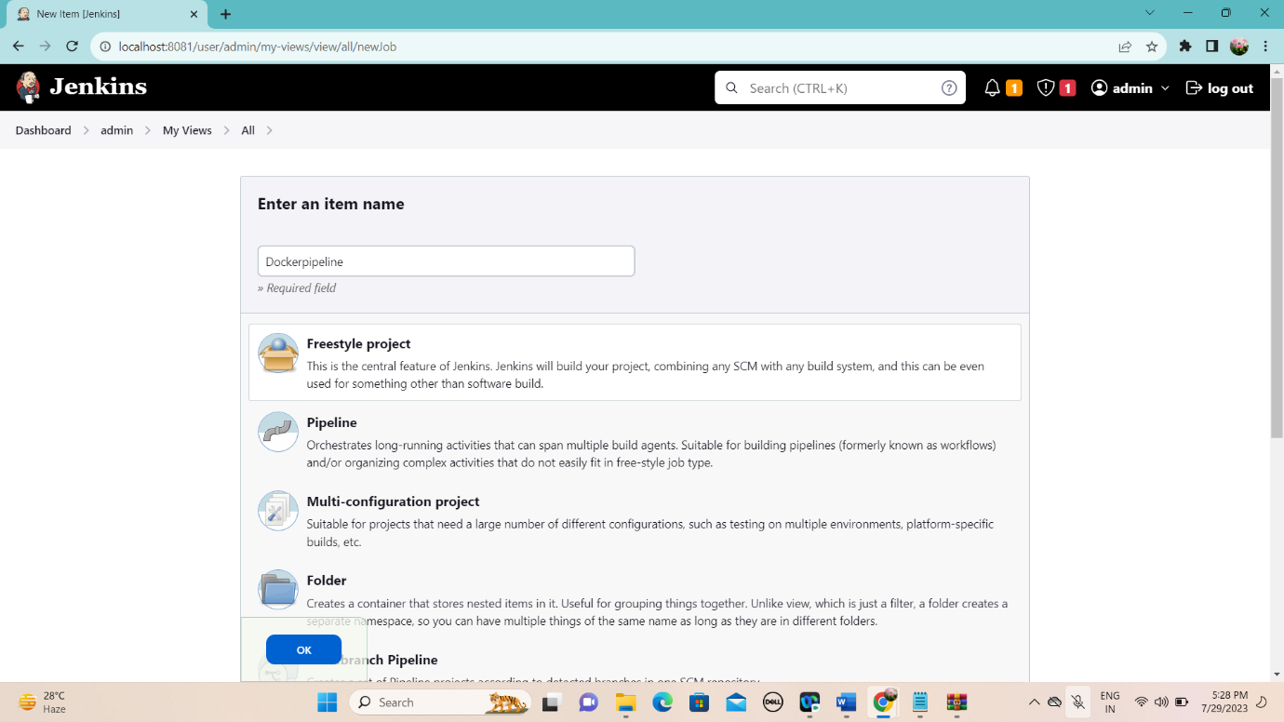

Configure Git repository so that we can have Dockerfile to build Docker container and push it to Docker Hub

https://github.com/awtraining1/sl.git

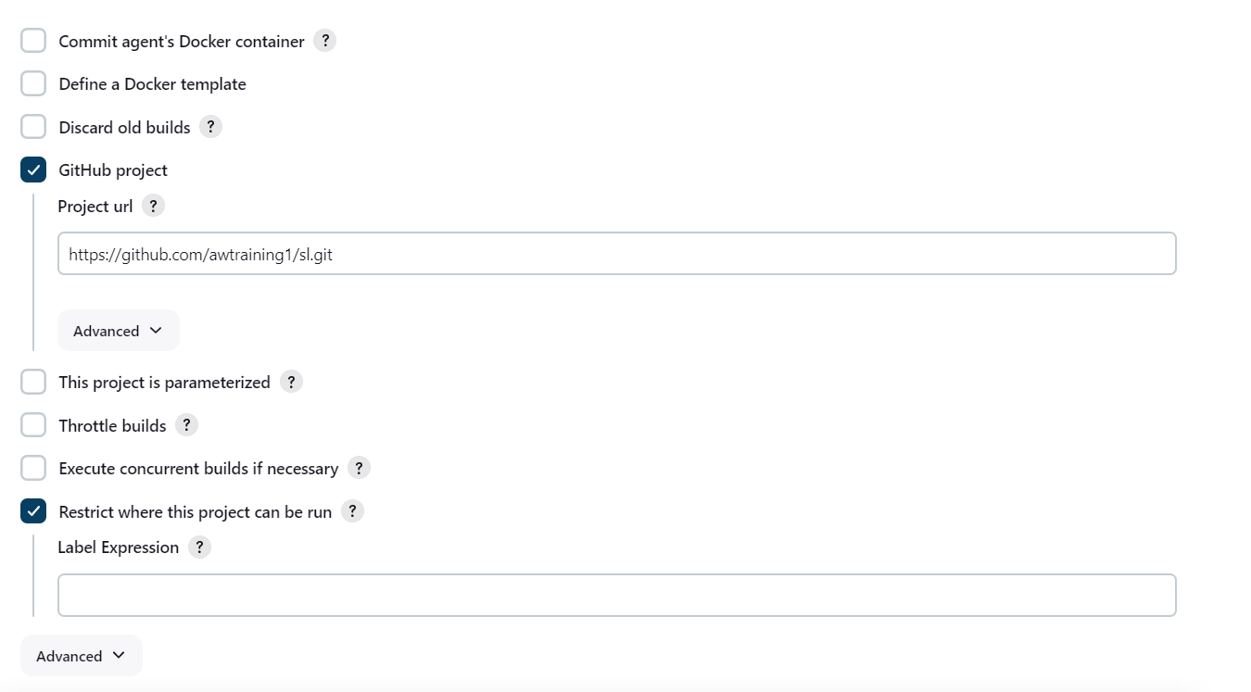

Configure build triggers to enable Poll SCM feature so that once any push is detected

